*HR Insights Unveiled : Excel Analytics Dashboard*

Priyesh Kumar   
Dept.Of Computer Science and Engineering  
Student at Lovely Professional UniversityPhagwara, India  
priyeshkumar554@gmail.com

Ms. Veerpal Kaur  
Dept. Of Computer Science and Engineering  
Ass. Prof. at Lovely Professional UniversityPhagwara, India

Veerpal.25909@lpu.co.in

*Abstract*— *In today`s dynamic organizational landscape, human resources (HR) specialists face the venture of creating knowledgeable choices amidst a deluge of data. This paper gives an progressive method to HR analytics via the improvement of an Excel-primarily based totally analytics dashboard. By leveraging the electricity of Microsoft Excel, this dashboard gives a complete answer for HR specialists to release precious insights from their data. Through the combination of numerous HR metrics and visualization techniques, this dashboard offers a user-pleasant interface for exploring trends, patterns, and relationships inside HR data. The implementation of this Excel analytics dashboard empowers HR groups to power strategic decision-making processes, optimize body of workers management, and beautify organizational performance. This paper elucidates the layout principles, functionalities, and advantages of the proposed Excel analytics dashboard, demonstrating its capability to revolutionize HR analytics practices and release the total capability of human capital inside organizations.*

Keywords— HR analytics, Excel-based dashboard, Data visualization, Strategic decision-making, Workforce management, Organizational performance, Human capital, Metrics integration, Trend analysis, Insights discover.

# Introduction

Human Resource Analytics (HRA) has come to be a pivotal device for groups in shaping their HR techniques. It includes the gathering of tremendous statistics on diverse HR sports and functions, that's then analyzed the use of suitable statistical gear and supplied via diverse dashboards. This systematic visualization of statistics gives sparkling insights, facilitating the formula of powerful HR techniques. HRA establishes a right away correlation among HR sports and the Return on Investment (ROI) of the organization, emphasizing its strategic importance. This monograph ambitions to discover the usage of HR dashboards in describing and deciphering HR statistics.

HR Analytics is a statistics-pushed framework applied to deal with group of workers challenges. It encompasses the gathering of numerous HR-associated statistics, software of statistical gear, and presentation of consequences to derive insights for formulating HR techniques. The number one goal of HR Analytics is to decorate organizational decision-making regarding human capital investments, expertise control, and HR practices through studying their effect on ROI. It aligns HR sports with organizational goals, emphasizing group of workers overall performance development primarily based totally on beyond statistics insights and destiny predictions. HR Analytics holds sizable promise for the destiny, reworking HR from a guide characteristic to a strategic enterprise partner. Human Resource Analytics (HRA) has emerged as a vital device for groups striving to formulate powerful HR techniques in today`s dynamic enterprise environment. By leveraging statistics-pushed insights, groups can higher apprehend and deal with group of workers challenges, including attrition, expertise control, and worker overall performance. This monograph ambitions to discover the usage of HR dashboards in describing and deciphering HR statistics, with a specific consciousness at the variables supplied withinside the dataset. The dataset consists of a complete array of variables shooting diverse elements of worker demographics, process characteristics, and organizational factors. These variables embody important dimensions including attrition status, enterprise tour frequency, departmental affiliation, instructional background, and marital status, amongst others. Through the evaluation of those variables, groups can benefit treasured insights into worker behavior, engagement, and retention.

Furthermore, the dataset encompasses key HR metrics including education attendance, overall performance ratings, process delight levels, and tenure-associated factors. These metrics offer deeper insights into worker development, organizational culture, and usual group of workers effectiveness. By delving into the intricacies of HR analytics and dashboard usage, this monograph seeks to shed mild at the transformative capability of statistics-pushed HR practices. Through the mixing of HR analytics gear and methodologies, groups can decorate decision-making processes, optimize group of workers control techniques, and in the long run power sustainable enterprise growth. Attrition analysis on a data dashboard gives a complete review and summary of important HR factors that assist in making healthy decisions and taking important steps about a company's employees. Different type of graphs and charts is used in creating data dashboard that helps to see patterns and trends, it reflects important information about differences or inequalities. If there is a significant increase in men leaving their jobs during a certain time, it may mean that there are specific problems related to gender or the workplace that need to be resolved. This analysis is helpful for top management to make decisions and change their policies and strategies. Color coding is a powerful tool within Excel that enhances the presentation and comprehension of data, particularly in contexts like human resources where understanding patterns and trends is crucial. Excel's conditional formatting feature enables users to automatically format cells based on specific criteria, such as attrition rates.

By setting up rules within conditional formatting, cells can be highlighted with different colors, making it effortless for HR teams to pinpoint areas with varying levels of attrition. Furthermore, Excel offers additional options like data bars and color scales within conditional formatting. Data bars visually represent cell values with horizontal bars of differing lengths, while color scales apply gradients to cells based on their values, allowing for clear visualization of attrition rate variations across different fields or departments. Additionally, Excel's conditional formatting includes icon sets, allowing users to add icons like arrows or checkmarks to cells based on their values, providing yet another means of visually representing attrition rates or progress in specific areas. Overall, Excel's versatile conditional formatting tools empower HR teams to efficiently analyze and act upon data insights, facilitating the development of targeted strategies and practices to improve employee retention and organizational progress.

**RESEARCH QUESTIONS**

* What are the significant predictors of employee attrition within the organization based on the provided dataset variables?
* How does business travel frequency impact employee retention rates and overall attrition levels?
* What is the relationship between demographic factors (such as age, gender, marital status) and employee attrition?
* How do job-related variables (such as job role, job level, overtime, training attendance) influence attrition rates?
* What role does job satisfaction play in mitigating attrition risk among employees?
* Are there any patterns or trends in employee performance ratings and their correlation with attrition?
* How does work-life balance, as indicated by variables such as work-life balance score and years at the company, affect attrition rates?
* What is the impact of organizational factors (such as department affiliation, environment satisfaction, and relationship satisfaction) on employee attrition?

## **RESEARCH OBJECTIVES**

* Identify the key predictors of employee attrition by analysing the relationship between demographic factors, job-related variables, organizational factors, and attrition rates.
* Examine the impact of business travel frequency, job satisfaction, work-life balance, and other relevant variables on employee retention within the organization.
* Explore patterns and trends in employee performance ratings, training attendance, and tenure-related factors to understand their association with attrition propensity.
* Assess the interaction effects among predictor variables to identify potential moderating factors influencing employee attrition.
* Provide actionable insights and recommendations for organizational leaders to develop effective HR strategies aimed at reducing attrition rates and enhancing employee retention.

# REVIEW OF LITERATURE

P. Singh, R.K. Upadhyay M. S., 2017 [1] Managerial Implications of HR analytics is not a one department problem solution tool rather it is a comprehended data system design to support the Academic learner, administrator & decision makers of the higher education institutions. It proves a comprehensive informatics to handle various challenges and opportunities existing in educational environment to manage between student demands, upraising industry benchmarking, liaison with government regulations, meeting the norms of accreditation society. Understand the analytical frame work and especially human resource domain can have a significant mark in the institutional growth. Thus, providing a considerable thought to the dynamics of academic community hiring & retention analytics is the need of the day. Thus, in total understanding and acceptability of HR analytics is a proven as a new strategic tool to enhance the efficiency and organizational excellence.

P. R. Reddy ,P. Lakshmikeerthi,2017 [2] The business world today is more specific in optimistic utilization of resources. As Human resources are the prime valued sources of any organization, more attention needs to be paid on this. All important decisions have been primarily evidence based. HR Analytics is not only driving best HR decisions with accurate evidence, but also provoking organizations to maintain adequate quality data for justifying ROI in HR Investments.

Vargas R, 2015 [3] This study indicates that performance expectancy, effort expectancy, fear appeals and social influence, are the most important factors in the HR professionals’ decision to use HRA. This comes as no surprise, since HR professionals, for the most part, spend most of their time in relationship building and utilizing their soft skills. Recently, the term human resource business partner (HRBP) has been discussed in recruiting HR professionals, but only in the context of a title. A true business partner must understand the actual business. Therefore, HR professionals should take note of the latest trends in analytics and begin to consider using HRA, if they seek to become a true strategic partner of the organization and earn a seat at the executive table. More than simply measuring performance and identifying prime candidates, human resources analytics is fast becoming an HR team’s crystal ball—a powerful predictive tool that can help anticipate performance levels, end poorly designed compensation models before they are rolled out and flag potential risks like disgruntled workers. By doing so, HR analytics is certain to become an increasingly indispensable tool for attracting, retaining, and optimizing talent.

M.O. Fred, 2017 [4] Development of HR Analytics using the management fashion theory as a theoretical backdrop. In the present day, every organization focuses its attention on aligning its HR strategy with overall organizational goals. The rapid changes in the business currently are causing intense competition among organizations. Hence to have an upper hand over these competitors, organization must establish HR Analytics for yielding accurate and real time information using employee’s data. HR Analytics thus help the organization to design a strategic workforce planning by analyzing every aspect of manpower data in the organization.

E. Houghton, J. Miller, 2015 [5] Without the mix of standard measures and context-specific indicators, HR professionals in the region believe that they will be unable to maximize the value generated through HR analytics. HR professionals who can secure investment are likely to gain the most from early high value insights for their businesses, and in a competitive economic environment such as south-east Asia, those organizations able to move first are often the most likely to make considerable gains against the competition.

G. Talukdar,2016 [5] HR analytics as a part of BI helps an organization in systematically handling Human Resources with the use of data management and warehousing technologies across different functions of HRM. Thus, it leads to work force stability within the organization. On the other hand, a stable work force leads to continuous business growth and helps an organization in its sustainability and thereby creates competitive advantage for the organization in its external business environment

L. Bassi, McBassi & Company 2011,[6] HR analytics is an evidence-based approach for improving individual and organizational performance by making better decisions on the people side of the business. But it can result in an elevation of the status of the profession and its practitioners by helping them to guide their organizations in finding the sweet spot—the intersection between more profitable and more enlightened management and development of people.

M.O. Fred,2017 [8] Intense global competition and the fast development in technology is forcing organizations to change its basic strategy. In the present day, every organization focuses its attention on aligning its HR strategy with overall organizational goals. The rapid changes in the business currently are causing intense competition among organizations. Hence to have an upper hand over these competitors, organization must establish HR Analytics for yielding accurate and real time information using employee’s data. HR Analytics thus help the organization to design a strategic workforce planning by analyzing every aspect of manpower data in the organization.

J Van Dooren, 2012 [7] This study has been focused on the applicability of HR analytics in relation to the contextual factor’s competitive intensity, organization’s age, organization’s structure, organization’s size, labor capital ratio, organization’s strategy, organization’s financial health and trend/hype of HR analytics. To assess the influence of those contingency factors on the applicability of HR analytics, the following problem statement has been investigated

# METHODOLOGY

The methodology employed for crafting the HR Insights

begins with meticulous data collection from organizational

databases, encompassing a wide array of HR metrics ranging from employee demographics to performance indicators and attrition records. This data is meticulously curated to ensure integrity and accuracy, undergoing rigorous validation and cleaning processes. Subsequently, the dashboard's design is meticulously planned, with clear delineation of objectives and key performance indicators (KPIs) aligned closely with organizational goals and HR priorities. Visualization tools and chart types are carefully selected to effectively communicate HR insights and trends, with a focus on user-friendly navigation and interpretation. Interactive features such as filters and slicers are integrated to enable dynamic data exploration.

Following data processing and analysis within Microsoft Excel, the dashboard undergoes development, characterized by the creation of visually compelling charts, graphs, and tables. These visual elements are enriched with conditional formatting and colour coding to highlight significant insights, such as areas of high attrition or performance disparities. Moreover, dynamic elements and interactivity features are incorporated to enhance user engagement and facilitate deeper data exploration. Thorough testing and validation ensure the functionality, accuracy, and performance of the dashboard, with adjustments made based on user feedback and evolving business requirements. Continuous improvement is emphasized, with ongoing monitoring of dashboard usage and effectiveness, coupled with regular updates and enhancements to maintain relevance and impact in facilitating data-driven decision-making within the organization.

# DATA ANALYSIS & INTERPRETATION

The dataset, comprising more than 1500 meticulously collected data points from a prominent company, serves as a comprehensive repository of information crucial for understanding the intricate dynamics of its workforce. Each data point encapsulates various facets of employee behaviour, performance, and demographic characteristics, providing a holistic view of the organization's human capital landscape.

Highlighted within this dataset are essential variables such as Attrition, Business Travel frequency, CF_age band representing age groups, CF_attrition label indicating attrition status, Department affiliation, Education Field, Employee Number, Gender distribution, Job Role diversity, and Marital Status composition. The meticulous curation of this dataset enables researchers and HR professionals alike to delve deep into the intricacies of employee attrition, discern patterns, and identify trends that may influence organizational outcomes. By examining the interplay between these variables, researchers can gain valuable insights into the factors driving attrition rates, as well as potential areas for intervention and improvement.

The inclusion of a subset of 70 records within this paper serves the dual purpose of providing a representative sample for analysis while also enhancing readability for the reader.



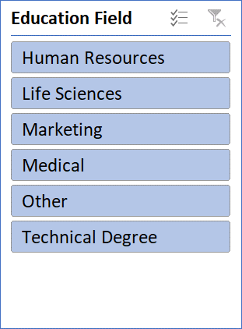

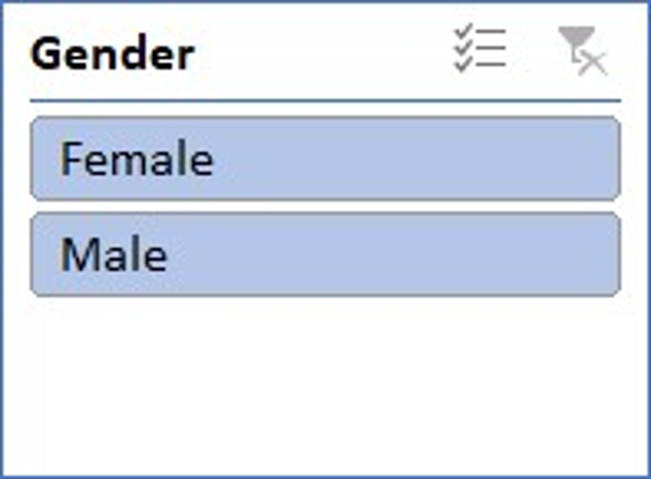

**i) Average Job Satisfaction and Rating Balance Evaluation**



**ii) Gender Distribution in Employee Count**

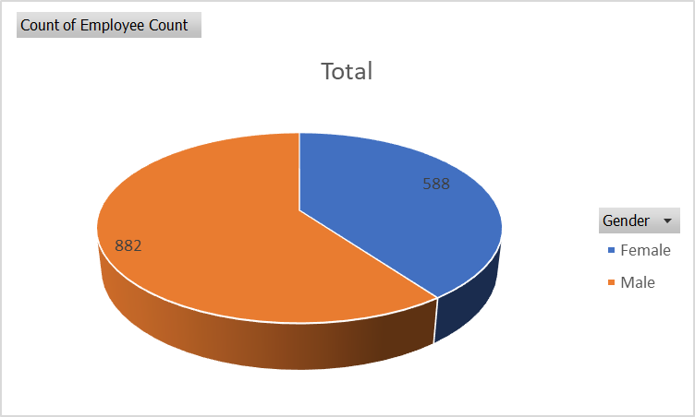

**iii) Attrition Count by Education Level**

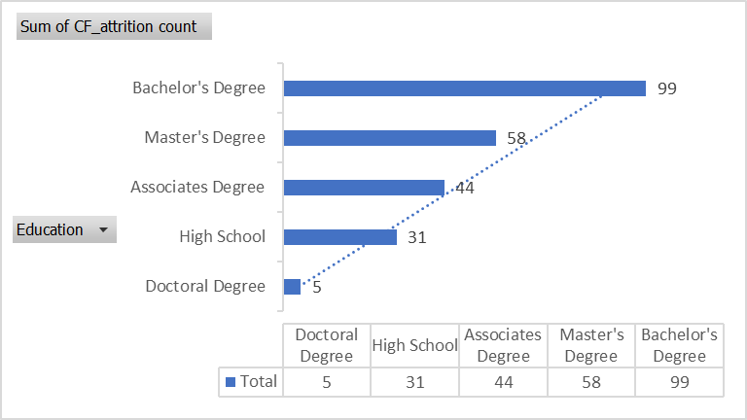

**iv) Attrition Count by Job Role**

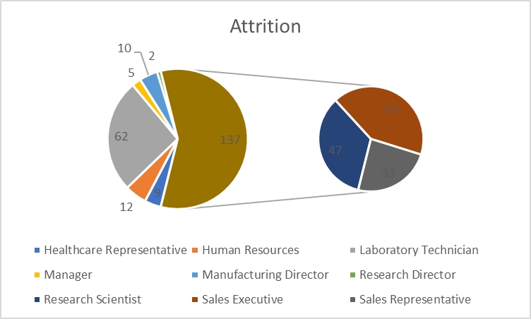

**v) Attrition Count by Department**

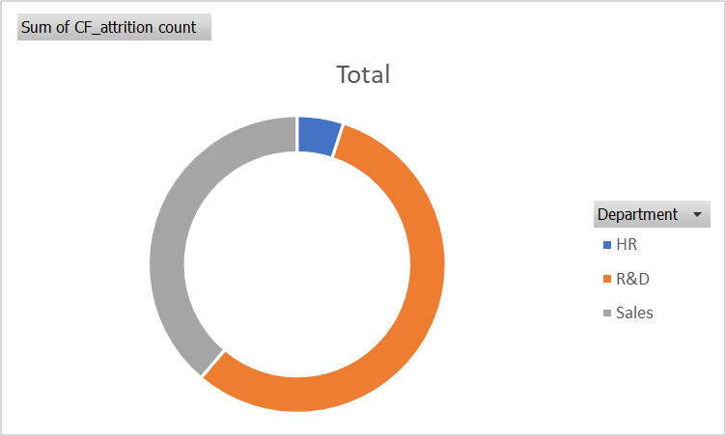

**vi) Attrition Count by Age**

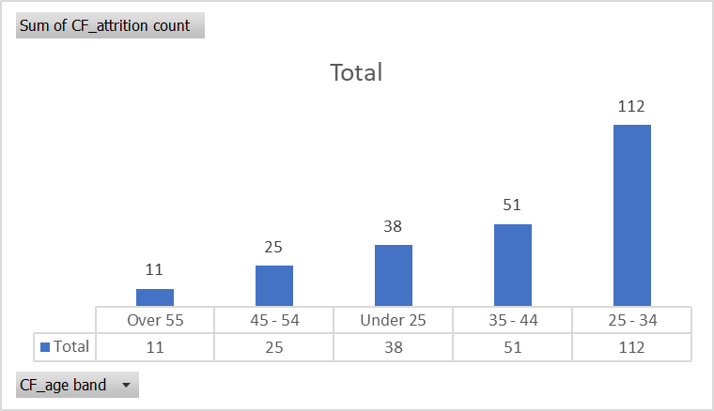

# CONCLUSION

In conclusion, the thorough evaluation of the dataset offers priceless insights into the multifaceted nature of worker attrition inside the organization. From dissecting demographic distributions to scrutinizing attrition fees throughout numerous process roles and academic backgrounds, the findings light up crucial styles and trends. These insights underscore the importance of enforcing centered retention techniques that renowned the various wishes and demanding situations of personnel throughout exclusive demographics and process functions. By leveraging those insights, companies can proactively deal with attrition danger factors, foster a subculture of inclusivity and support, and in the long run domesticate a resilient team of workers poised for sustained success. Moving forward, endured data-pushed evaluation and strategic interventions may be paramount in riding organizational growth, improving worker satisfaction, and securing long-time period viability in today`s dynamic commercial enterprise landscape.

# FUTURE SCOPE

The evaluation of Hr attrition withinside the corporation opens up numerous avenues for destiny studies and strategic tasks. Some ability regions for in addition exploration and improvement include:

1) Longitudinal Analysis: Tracking attrition traits through the years can offer precious insights into the elements using worker turnover. This entails studying historic records to become aware of styles and adjustments in attrition rates. By information those traits, businesses can verify the effectiveness in their retention techniques and make essential adjustments.

2) Predictive Modelling: Employing superior analytics and system getting to know strategies to increase predictive fashions for worker attrition can assist businesses count on and mitigate turnover threat greater effectively. These fashions can become aware of early caution symptoms and symptoms and high-threat employees, allowing proactive interventions to enhance retention rates.

3) Employee Engagement Surveys: Conducting normal worker engagement surveys lets in businesses to collect comments on elements influencing process pride, motivation, and retention. By without delay soliciting enter from employees, businesses can become aware of regions for improvement, deal with concerns, and improve worker engagement and loyalty.

4) Diversity and Inclusion Initiatives: Investing in range and inclusion tasks fosters a greater inclusive and supportive place of business environment, that may lessen turnover amongst underrepresented groups. By selling range in hiring and management improvement, businesses can decorate worker retention and free up the entire ability in their workforce.

5) Talent Development Programs: Implementing capabilities improvement packages and supplying profession development possibilities can assist preserve pinnacle performers and high-ability employees. By making an investment in training, mentorship, and expert improvement tasks, businesses display a dedication to worker boom and development, in the end lowering turnover and growing worker pride and loyalty.

6) Flexible Work Arrangements: Providing bendy paintings alternatives inclusive of far off paintings, bendy hours, and compressed workweeks incorporates employees` numerous desires and preferences, enhancing paintings-lifestyles stability and process pride. Embracing place of business flexibility facilitates appeal to and preserve pinnacle skills at the same time as improving worker morale and productivity.

Additionally, the future of addressing HR attrition necessitates a holistic approach that considers the evolving needs and expectations of employees in the modern workplace. This involves adopting innovative technologies and digital tools to streamline HR processes, enhance communication, and provide personalized experiences for employees. Embracing a culture of continuous feedback and open dialogue cultivates trust and transparency within the organization, fostering stronger connections between employees and leadership. Moreover, fostering a culture of recognition and appreciation for employees' contributions cultivates a sense of belonging and loyalty, further reducing turnover rates. By embracing these forward-thinking strategies and fostering a dynamic and inclusive work environment, organizations can proactively mitigate attrition risk and cultivate a thriving workforce poised for long-term success.

##### References

1. Priyanka Singh, Rajesh Kumar Upadhyay & Dr. Monika Srivastava,The Role Of Hr Analytics In Higher Education Institution’, International Journal Of Engineering Sciences & Research Technology (2017),Pg.No.92-100
2. Dr. P. Raghunadha Reddy,**P. Lakshmikeerthi,(2017)‘HR Analytics’ - An Effective Evidence Based HRM Tool, International Journal of Business and Management Invention, Pg No- 23-34.
3. Roslyn Vargas, (2015) Nova Southeastern University NSUWorks, Adoption Factors Impacting Human Resource Analytics Among Human Resource Professionals, Pg No-1-90
4. Masese Omete Fred, (2017), IOSR Journal of Business and Management (IOSR-JBM), Workforce Analytics the Prospect of Human Resource Management, Pg No- 8-13.
5. GitikaTalukdar,(2016), International Journal of Computer Sciences and Engineering, Human Resources Analytics: An Approach Towards Business Intelligence, Pg No-125-129
6. Laurie Bassi, McBassi & Company,(2011), PEOPLE & STRATEGY, Raging Debates in HR Analytic, Pg No-15-17
7. Joerik van Dooren, 2012, HR Analytics in Practice , An overview of the influence of contingency factors on the applicability of HR analytics in Dutch organizations Pg No-3-29.
8. Masese Omete Fred,(2017), IOSR Journal of Business, and Management, Workforce Analytics the Prospect of Human Resource Management, Pg No- 8-13
9. Wen, X., Wang, X., Wen, X. and Wang (2020).Advancing Educational Research with Emerging Technology.IGI Global. Available at:https://scholarworks.utrgv.edu/cgi/viewcontent.cgi? article=1113&context=is_fac. (Accessed 3 November 2023).
10. www.slideteam.net. (2020). Department-wisechart showing attrition of employees. Available at: https://www.slideteam.net/department-wise-chart-showing-attrition-of-employees.html (Accessed 2 November 2023).
11. Paul F Dr. Jack Fitz- Enz, Lexy Martin, HR Analytics: Driving Return on Human Capital
12. Investment, An Oracle White Paper, (2017), Pg No 3-21
13. airhurst,(2014), IES Perspectives on HR, Big data and HR analytics, Pg No-2-6